Ergonomic Needs Assessment
Brought to you by your friendly neighbourhood OH&S Committee.

- Please use felt to mark off parts of the body where you feel pain and/or discomfort, while you are at work.
- Please note the probable cause of your injury / injuries.
- Please note where you injury / injuries took place (e.g. Home, work, etc.)

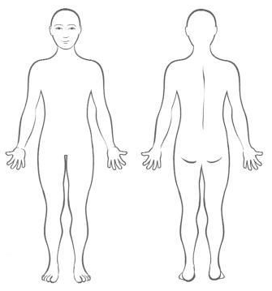

Probable Cause of Injury | :
Where injury took place  (e.g. Home, work, etc.) | :

